|  |  |
| --- | --- |
|  |  |

Ericsson Order Care Business Guide

Contents

1 Abstract 2

2 Market Situation 2

2.1 Market Background 2

2.2 Current Market Situation 3

2.3 Current Market Share 4

2.4 Market Trends and Impact for Ericsson 5

3 Target Customer 8

4 Our Offering 10

4.1 Description 10

4.2 Customer’s Business Environment 12

4.3 Pricing Principles 12

5 Customer Benefits and Value Argumentation 12

5.1 Market Message 12

5.2 Value Argumentation 14

5.3 Business Case 17

6 Sales Approach 17

6.1 Sales and Differentiation Strategy 17

6.2 Customer communication 18

6.2.1 If you only have 10 seconds, say this: 18

6.2.2 If you have 10 minutes, say this: 18

6.2.3 If you have one hour, say this: 19

6.3 Sales activities 19

6.4 Commercial Attention 20

6.5 Tactical Aspects 20

7 Customer Project Approach 20

8 Competitive Situation 21

# Abstract

Fixed and mobile executives who are responsible for the operations and IT aspects of product enablement face the challenge of speeding the time and minimizing the costs of launching and delivering services. Ericsson Order Care provides is a proven order management platform for creating and orchestrating automated workflows and manual work activities across services, systems, processes and groups.

It automates the orchestration of complex service order structures through validation, decomposition, order processing, routing and status tracking. It also handles manual work items with load balancing and prioritization, while supporting project management activities to direct appropriate workloads to staff personnel. End-to-end visibility of process status is delivered via reports and dashboards to facilitate business decision-making.

This means that cleaner service order processing and faster completion of manual work items can be achieved by enforcing consistent service order management and provisioning control. Customers have reported reductions in order processing time on the order of 96% with service order flow-through rates on the order of 95%.

Unlike our competitors, Ericsson provides a comprehensive solution to seamlessly manage automation along with manual activities to enable end-to-end operational flow-through and visibility.

# Market Situation

## Market Background

The communications industry is being overwhelmed by increasingly complex services that need to be accessed from a variety of ordering vehicles from any type of delivery channel. The biggest struggle for both fixed and mobile operators is to have end-to-end visibility into all service orders across all product lines while reducing operational costs. And timeliness is of the essence – in terms of both service launch and service delivery. Success demands a standard, repeatable and structured approach and proven best practices.

While operators are keenly focused on gaining operational efficiencies via process automation, many have failed to implement effective methods to handle those activities that cannot be automated. And even those activities that have been automated may eventually break at some point thus requiring efficiently coordinated human intervention.

Most current solutions cannot consistently coordinate and complete these types of activities across services, supporting systems, business processes, and work centers. This lack of coordination results in operational errors and delays, and fails to provide the kind of feedback needed to drive process and organizational improvements. In addition, operators may not have the tools needed to adequately assess areas for improvement.

## Current Market Situation

In its 2013 service fulfillment forecast report, Analysys Mason indicated that total global operator order management software will generate revenue of over USD800 million by 2015 (see figure below). The revenue forecast includes license revenue plus maintenance and product-related services (but did not include integration revenue). In that report, Analysys Mason predicts that the order orchestration revenue will grow at a rate of 6.6% CAGR from 2012 to 2017.

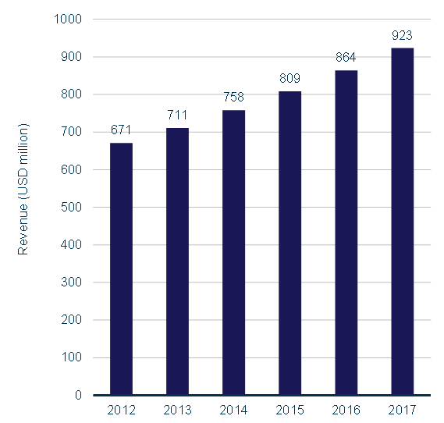

**Figure 1** Global Order Management Revenue Forecast [Source: Analysys Mason, 2013]

Analysis Mason also notes that, “around two-thirds of order management implementations are part of a full service fulfilment stack of systems, including order management, inventory management (with network discovery) and activation of one or more services.” As Ericsson has the broadest portfolio of OSS/BSS that includes a comprehensive fulfillment offering, there is ample opportunity for multi-product deals that hinge on Ericsson Order Care for order orchestration.

Prior to its acquisition by Ericsson in 2012, ConceptWave had long been a recognized leader in product catalog and order management solutions to the communications industry. Its success may be attributed to the fact that it was the only pure-play OSS order management vendor and therefore built its software purposely with efficiency in mind, not as a gap function gluing together other major OSSs.

## Current Market Share

The following chart from the Analysys Mason fulfillment 2012 market share report (published in 2013) shows Ericsson with 7.6% of the global Order Management market, but ConceptWave revenue is included in the “other” category. Next year’s report will show the combined Order Management market share. If ConceptWave had only 2% of the market in 2012, the combined total for Ericsson would have put us at the top of the list.

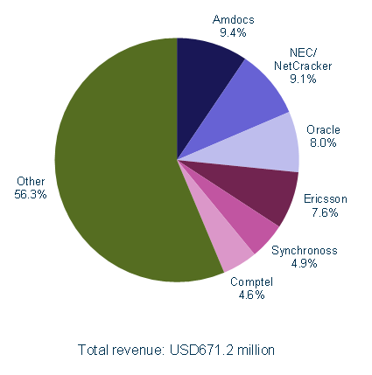

**Figure 2** Order Management Market Shares by Revenue, Worldwide, 2012  
[Source: Analysys Mason, 2013]

Ericsson Order Care and Ericsson Catalog Manager have been deployed at the world’s premier operators across the world. Notable examples are:

* **Americas:** Time Warner Cable, Charter, Comcast, Bell Canada, Rogers Canada, Verizon, TSTT, Videotron, MTS Allstream, CenturyLink, Telemar (Oi)
* **Europe:** Belgacom, Portugal Telecom, Swisscom, Turk Telekom, Telecom Italia, BMW, T-Hrvatski Croatia
* **Middle East and Asia:** CSL Hong Kong, TOT Thailand, Reliance, Saudi Telecom

New deployments include Telecom New Zealand, T-Mobile USA, and Ziggo. The Ericsson implementations utilize various features of the Ericsson suite of order management products.

## Market Trends and Impact for Ericsson

**General Service Fulfillment and Order Management Trends**

According to Analysys Mason, key market trends are:

* Service fulfilment projects are primarily driven by opportunities to increase revenue as it enables them to quickly and efficiently implement new services. However, cost reduction will continue to be an important consideration in project approval. *We continue to develop business case analyses that consider both revenue and cost components.*
* In the short term, the service fulfilment market is expected to grow at a higher rate than some other telecoms software segments. Growth will be driven by:
  + network evolution towards optical/packet technology
  + implementation of LTE and self-optimizing networks (SONs)
  + the desire for instant availability of complex service bundles
  + the need to operate in uncertain and changing business environments
  + deregulation of broadband and mobile services in emerging markets
  + the increasing desire to meet the needs of small and medium-sized enterprises
* In the long term, growth will also be driven by the new double-sided business offerings of CSPs, machine-to-machine (M2M) mobile services, cloud computing and storage services, small-scale national broadband infrastructure investment projects and renewed interest in system transformation projects.
* Tier 1 CSPs are increasingly implementing service fulfilment stacks for new services from a single vendor. In fact, two-thirds of order management deals are part of a full service fulfilment stack of systems. *With our #1 position in fulfillment OSS, Ericsson is in an excellent position to offer a comprehensive fulfillment solution.* The trend is also for vendors to deliver order management systems with a product and service catalog. *Ericsson is uniquely qualified with a proven pre-integrated catalog and order management solution.*
* Order management systems increasingly have capabilities for ‘in-flight’ changes to the orders, without the need to cancel and resubmit the entire order. *Ericsson Order Care is well-positioned in this capability.*

**Geographic Trends**

The following graph shows the market revenue forecast by region.

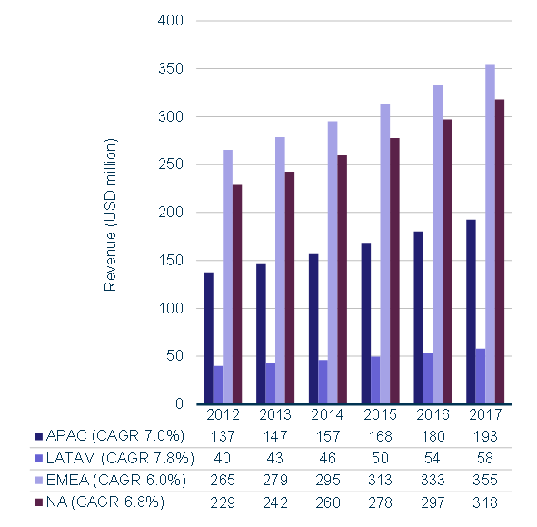

**Figure 3** Order Management Revenue by Region, Worldwide, 2012–2017 [Source: Analysys Mason, 2013]

**Mature Markets**: According to Analysys Mason, order management system revenue in the mature markets of APAC, EMEA and NA will increase modestly as CSPs extend the use of their established order management systems to new services. For vendors that have size-based pricing models, this means more revenue.

Analysys Mason points out that these CSPs will have to either extend their systems to support the new digital economy services, or purchase new service fulfillment stacks (including order management). *Note that we are launching a solution at Mobile World Congress 2014 to directly address digital service creation and delivery through our OSS, BSS, and Service Enablement systems.*

CSPs in mature markets in EMEA are implementing transformation projects to provide order management for new services more quickly and easily – with limited involvement from independent IT organizations.

**Emerging Markets**: CSPs in EMEA’s emerging markets are implementing the new generation of order management systems. Similarly, CSPs in APAC’s emerging markets will implement these new systems to provide flow-through ‘instant’ provisioning. Revenue in LATAM will grow as all CSPs implement new flexible order management systems to support their established and new services.

In terms of type of service, mobile services will continue to grow. Public Switched Telephone Network (PSTN) services will continue its decline, although Analysys Mason expects that investment in new order management systems will increase towards the end of the forecast period as operators begin to decommission their legacy PSTN systems.

The overall process for quoting, designing, ordering, and fulfilling business services will become more automated, driving growth in both the large enterprise and SME segments of the business services market.

According to Analysys Mason, the residential broadband segment will grow modestly, driven by growth in the complexity of service bundles, fiber to the x (FTTx) deployments, home networking and ‘over-the-top’ services, and software as a service (SaaS) offerings.

**Trends Based on Service Types**

The following graph shows the market revenue forecast by service type.

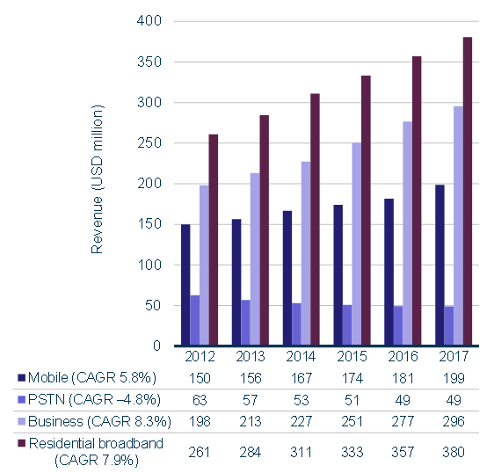

**Figure 4** Order Management Revenue by Telecom Service, Worldwide, 2012–2017 [Source: Analysys Mason, 2013]

**Mobile**: The mobile service segment will continue to grow in size and service complexity. Increasing demand for ‘instant service’ will drive growth, as will M2M, but the simplicity of the individual order components will limit the revenue growth in this segment. *Ericsson differs in opinion on this last statement. As new services more and more involve other parties, the complexity of managing and fulfilling the order becomes more complex.*

**PSTN**: The PSTN segment will continue its decline, although investment in new order management systems will increase towards the end of the forecast period as CSPs begin to decommission their legacy PSTN systems.

**Business**: The overall process for quoting, designing, ordering, and fulfilling business services will become more automated, driving growth in large, medium, and small enterprise segments.

**Residential Broadband**: Revenue will grow modestly, driven by the increasing complexity of service bundles, fiber deployments through government-sponsored stimulus plans, home networking, over-the-top services and SaaS offerings.

# Target Customer

In general, Ericsson Order Care is geared towards the needs of Operations and IT executives who want to primarily minimize the costs of service order processing and manual work activities. Increasingly, the trend is to want to offer new services more quickly, and provide linkages to third-party providers of service components. Processes are typically associated with service orders, infrastructure orders, assurance activities, or other tasks. Ericsson Order Care enables an increased level of standardization of complex processes.

The following tables show target customer profiles for various product contexts.

**Table 1** Target Profile for Enterprise and Wholesale Services

| **Overall Profile** | **New Customer** | **Existing Customer** |
| --- | --- | --- |
| * **For Operations executives at a wireline service provider** who want to reduce the time-to-provision service projects by better managing workflows and manual work items, and those who want to reduce rework * **For IT executives at a wireline service provider** who want to reduce the costs of implementing and maintaining the operational platform to fulfill service projects | **Required**   * Enterprise Services has to be the primary line of business or a major growth area * Sophisticated product offerings with multiple configurations and/or complex supply chain   **Optional**   * Stated focus on cost savings and efficiency, or acknowledged problems with service delivery process * No existing order management or inventory system (or legacy/in-house/old systems) * Standard usage of commercial off-the-shelf (COTS)-based project management tools | **Required**   * Enterprise Services has to be the primary line of business or a major growth area * Stated focus on cost savings and efficiency, or acknowledged problems with service delivery process * Sophisticated product offerings with multiple configurations and/or complex supply chain   **Optional**   * May already have other Ericsson products * Standard usage of COTS-based project management tools |

**Table 2** Target Profile for Mobile Services

| **Overall Profile** | **New Customer** | **Existing Customer** |
| --- | --- | --- |
| * **For Operations executives at a mobile operator** who want to reduce inquiries into the call center, provide more business process automation, reduce order processing delays for new mobile subscriptions or changes to existing subscriptions * **For IT executives at a mobile operator** who want to reduce the costs of updating systems when introducing new products, especially products that include components from third parties | **Required**   * Mobile services currently or envisioned to be among primary lines of business * New entrant or incumbent competing with other mobile operators who need to launch new services more quickly   **Optional**   * Stated focus cost savings and efficiency * Customer retention * IT transformation (antiquated order management and fulfillment systems), especially in-line with major network upgrade (e.g., LTE, IMS) * Standard use of COTS-based solutions | **Required**   * Mobile services among primary lines of business * New entrant or incumbent competing with other mobile operators who need to launch new services more quickly   **Optional**   * May already have other Ericsson products * May already be using Ericsson Order Care for fixed services * Standard use of COTS-based solutions |

**Table 3** Target Profile for Mass Market Broadband Services

| **Overall Profile** | **New Customer** | **Existing Customer** |
| --- | --- | --- |
| * **For Operations executives at wireline or cable companies** who want to enable business process automation and reduce order processing delays/rework for multi-play services over fiber-based access * **For IT executives at wireline or cable companies** who want to reduce the costs of updating systems when introducing new products | **Required**   * Fixed services among primary lines of business * Products offering of multi-play services * New entrant or incumbent competing with cable providers offering similar services   **Optional**   * Stated focus cost savings and efficiency * Customer retention * IT transformation (antiquated order management and fulfillment systems) * Standard use of COTS-based solutions | **Required**   * Fixed services among primary lines of business * Products offering of multi-play services * New entrant or incumbent competing with cable providers offering similar services   **Optional**   * May already have other Ericsson products * May already have Ericsson Order Care for another line of business * Standard use of COTS-based solutions |

# Our Offering

## Description

Ericsson Order Care is a proven order management platform for creating and orchestrating automated workflows and streamlining manual work activities across services, systems, processes and groups. It automates the orchestration of service orders through validation, decomposition, order processing, routing and status tracking.

With its order negotiation capability, Ericsson Order Care lets you manage the lifecycle of the customer and their orders. Using a user-friendly wizard of your own design, you guide customers through the order capture process, including quoting, selling, ordering, validating, and approving credit. These screens can be used by any channel – your customer service representatives, your partners, or via customer self-service.

With its powerful workflow engine and ability to coordinate manual work, Ericsson Order Care can be used in project management activities that typically have a longer-term duration than service orders, for example to support product management, provisioning, assurance, engineering, and network build projects.

Ericsson Order Care handles multi-site, multi-service order structures with configurable workflows along with flexible policies to fulfill partial orders, escalate stalled orders, and rollback failed or cancelled orders of any type. It also provides updates to external systems to reflect real-time order status.

Ericsson Order Care handles a range of manual work activities including projects, planned and unplanned work items, and exceptions. It coordinates and tracks these activities across disparate services, systems, and groups. The system provides enhanced distribution and management of work items through configurable business rules for work assignments, prioritization and load balancing methods, and data analytics. Work items can be prioritized by type of service, customer, geographic data, or other user-defined criteria, including configurable business flows.

The system’s reporting features provide end-to-end visibility of your processes so you can proactively manage and improve them, while its dashboards facilitate business decision making.

In short, Ericsson provides a complete order management solution on a single pre-integrated platform as shown in the figure below.

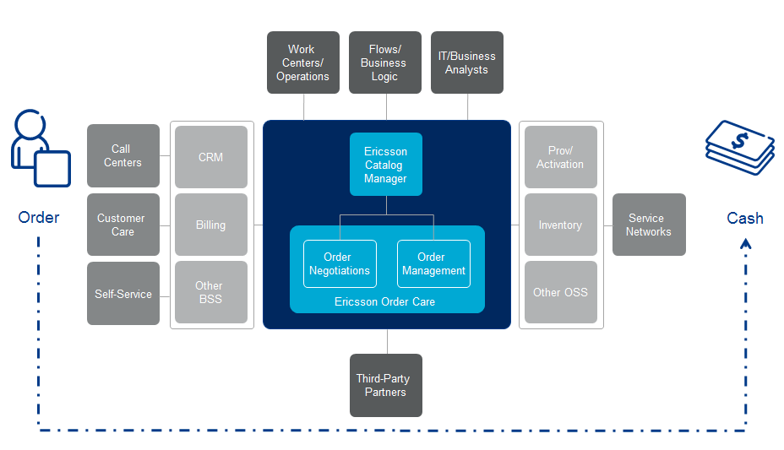

Figure : Ericsson Order Care Functional Architecture

The bulk of the work involved in an implementation is not related to the installation itself, but to the retrieval, analysis, translation, and validation of current configuration data.

*Note: further product information can be found in the Ericsson Order Care Commercial and Technical Product Descriptions on the Ericsson Product Catalog.*

## Customer’s Business Environment

The ability to call on a range of operational process expertise from Ericsson consultants or architects will help to ensure a good fit to customers’ business requirements, as well as any possible structural change or improvements required.

A consulting engagement should be focused on assessing and ensuring the seamless flow of service orders from the point of initiating the order through the entire provisioning process including dispatch and activation. This service also focuses on billing implications, service assurance processes and the work centers and systems that support these processes. Our recommendations and implementation plans ensure flow-through from order negotiation to order completion.

## Pricing Principles

The Ericsson Order Care pricing model is composed of value-based philosophy, where license fees are based on a number of factors:

* Software product components licensed
* Lines of business supported
* Usage Volumes:
  + Number of services offered
  + Number of orders or subscribers (per line of business)
  + Number of deployments (within certain lines of business)

For more information, please refer to the Sales and Ordering process specifically designed for Ericsson products.

# Customer Benefits and Value Argumentation

## Market Message

With Ericsson Order Care, operators can significantly improve their operational environment with faster, more accurate order management. Using a single system to manage and automate service order processing – one that typically relies on disparate systems and manual work activities – Ericsson software can help increase the ease and speed of launching new products and fulfilling resulting orders. With a meta-data driven platform to create, customize and maintain consistent business rules, logic and workflows, the level of flow-through processing can be increased while ensuring that appropriately-qualified people are assigned a prioritized and balanced work load. Finally, with a customizable analytics and reporting framework, operators can proactively manage and improve your processes, track status trends, and analyze historical information, all driving continuous process improvement.

The following table summarizes the value points of Ericsson Order Care.

Table Ericsson Order Care Value Matrix

|  |  |
| --- | --- |
| Benefit and Typical Results | How Ericsson Order Care Helps |
| More efficient order management   * 96% reduction in order processing time * 90% reduction in manual work item handling time * 95% service order flow-through | * Increase service order flow-through via mechanized process coordination involving both automated workflows and manual work activities. * Proven best practice experience in data and process modeling.   + Reduce manual work item handling time by prioritizing and balancing workloads across systems and groups.   + Process improvement with end-to-end operational visibility and real-time access to data. |
| Faster error handling   * 33% less staff required to manage manual work | * Less staff required to manage manual work by optimizing staff utilization with business rules that prioritize and route work to the most appropriate person.   + Expedite the resolution of errors by gathering and providing timely, relevant information. |
| Superior customer experience with first-time-right order fulfillment   * 95% service order flow-through * 80% reduction in missed due dates | * Enforce consistent and repeatable business processes – including moves, adds, changes, deletes, cancels, and suspend processes. * Provide tools for continuous process improvement. * Reduce missed dates by coordinating among automated service order workflows and manual work activities.   + Increase efficiency by enabling end-to-end visibility of operational performance. |

The following provides information sources and assumptions for the value propositions:

* **96% reduction in order processing time** – based upon the operational results from an European operator where Ericsson Order Care reduced the time it took to process service orders and send them to their provisioning team (for activation) from two days down to two hours per order.
* **90% reduction in manual work item handling time** – based upon the operational results from a North American operator.
* **Threefold increase in manual work items managed** – based upon the operational results from a North American operator.
* **33% order entry headcount reduction** – based upon the operational results from a CALA operator and a North American operator.
* **95% service order flow-through** – this is a metric consistently proven in our deployments.
* **80% reduction in missed due dates** – based upon the operational results from a North American operator.

## Value Argumentation

Ericsson Order Care addresses issues at multiple levels and in multiple groups within an operator. The following summarizes common entry points and areas of value per main target group.

**Current Situation for Operations Including Network Operations Center**

Many current operational environments still lack one common, automated order processing platform to handle the growing number of services. Isolated stacks require specialized expertise that may be limited to only one stack. As a result, staff productivity is diminished and the ability to quickly launch new services is limited by the existing rigidity in the fulfillment chain.

Moreover, when an order fails, it is difficult to track its status because it separately needs resolution at multiple systems or departments. Legacy order management systems typically do not provide an end-to-end view of the status of an order and its suborders. Rollback on errors is not centrally managed nor tracked. In general, the handling of errors and process exceptions is inconsistent and prone to errors.

Current operational environments typically lack a centralized platform that provides consistent handling of manual activities that arise in the normal course of business, for example in planning/engineering of networks and in fulfilling and assuring services. Tracking the status of these activities is difficult due to the lack of end-to-end visibility across the multiple systems, departments and individuals that typically are involved in handling these activities.

Reporting is often an exercise in accounting for what happened – not what’s happening right now, and the results are based on inconsistent and incomplete information.

From a service perspective, there is no common operational platform in place to handle the various products and subtending services typically included in both fixed and mobile offerings. Each order may be handled by multiple separate systems, depending on the service mix being requested, making it difficult to determine the primary owner of an order. In addition, provisioning of more complex enterprise services is mostly manual and inconsistent from technician to technician.

**Benefits to Operations**

* Single system that automates a majority of order management needs with a common approach to manage and track service order progress, coordinate any manual activities/exceptions, and manage the resolution of any order errors including rollbacks. Manual provisioning of multi-play services can take hours. Our flow-through solution takes the service request from order management to activation in minutes – no touch. Service order flow-through accounts for a savings of at least 20 minutes per order.
* Reduction in service order processing time on the order of 96% while achieving service order flow-through rates on the order of 95% due to cleaner order processing with less manual processes and rework.
* Faster resolution of order errors by a combination of centralized reporting and dashboards, automation, and more efficient assignment and prioritization to get the right people or systems involved at the right time.
* Increased productivity by enforcing consistent methods and procedures, and by providing the tools to understand and incrementally improve operational processes.
* Less training by using a single platform to handle any required manual steps, along with enhanced ability to adapt to new services, systems, and organizational changes.
* More diverse staff by bridging planning and engineering, fulfillment, and assurance into a more cohesive operational environment.
* Reduction in order-entry staff needs on the order of 33% due to system consolidation and process automation.
* A single system mechanizes enterprise service project coordination with a common approach to manage and track progress, coordinate any manual activities/exceptions, and manage the resolution of any order errors including rollbacks. Supporting flow-through rates of 90% or higher.
* Improved call center performance as a result of ease of use of navigation and access to relevant data enables customer service representatives to reduce their average call center call time by 20%.
* Decreased customer churn due to higher visibility of customer products, services, and account information.
* Reduction in order exceptions initiated in call centers.

**Current Situation for IT**

Many IT organizations rely on various separate systems or approaches to effectively handle the various types of orders and associated manual activities. They typically lack a common platform that orchestrates legacy and next generation operational systems.

Customizing currently deployed provisioning platforms is labor-intensive – usually involving long lead times. Specialized knowledge and development tools are required to run and maintain these platforms as well as the associated middleware. It takes too long to develop provisioning capabilities to support a new device or service. It takes too long to modify these platforms when there is a service request change.

IT organizations need a way to serve their operational groups with a cohesive package that facilitates completing work on time with the fewest possible resources. They also need a system that is robust with little down time and that can be configured or customized to fit changing business needs.

**Benefits to IT**

* Rapidly maintain and change business logic and workflows using a modularized, component-based, metadata-driven approach with graphical tools
* Rapidly and effectively integrate process flows across disparate systems and groups using an extensible data model
* Reduced operational costs via integrated reporting tools
* A single platform providing data and process consolidation
* Enables any department to understand workload across all areas
* Allows for incorporation of third-party assets and their associated workflows
* Reduction in training costs – the average time to train an end-user on Ericsson Order Care is five days

## Business Case

With Ericsson Order Care, operators can significantly improve their operational environment by:

* Using a single system to manage automated service order processing and manual work activities.
* Relying upon a metadata-driven platform to create, customize, and maintain workflows and business logic.
* Using more detailed reports and analytics to drive continuous process improvement.

The business case is typically based on some combination of:

* Reduced time and cost to deploy new services – workflow and business logic customization.
* Reduced time and cost to process service orders – coordination, automation, reduced swivel chair; 20-30% savings when compared to systems with substantial automation, and even greater savings for manual processes.
* Greater throughput and flow-through of service orders creating a standard but flexible process – automated provisioning, less service order fallout, more flexible rollback, and faster order rework.
* Avoiding the need to increase headcount upon new service rollout.
* Reduced penalties from SLA breaches.
* Retirement of legacy systems – system consolidation; mapping multiple services to a single traceable process.

# Sales Approach

## Sales and Differentiation Strategy

Ericsson Order Care enables operators to provide catalog-driven order negotiation and order management. It provides process automation and manages manual work activities, while providing end-to-end visibility of order status. It speeds up idea-to-implementation and order-to-service and boosts productivity with a combined service order and task management system that guides orders through the entire workflow process, and coordinates manual work activities across services, systems, processes, and groups.

Ericsson Order Care’s open design enables integration with existing environments without recoding and data duplication. It acts as the bridge between BSS, OSS and Service Delivery Platforms (SDPs) to provide catalog-driven fulfillment, assurance, and billing across multiple services. It reduces the cost and time to complete orders through systematic distribution of accurate, timely information to the appropriate people and systems.

The Ericsson Order Care architecture was purpose-built with system integration in mind to support complex services in complex operational environments – providing order status updates to CRM and other systems for higher accuracy of operational and billing data. It benefits from the broadest/deepest telecom expertise to maximize back-office data transparency, process automation, and staff utilization.

Ericsson’s proven best practice experience in data and process modeling is reflected in workflow enablement that can handle the most complex processes and it comes with a business process library for faster workflow creation.

## Customer communication

### If you only have 10 seconds, say this:

Are your operations capable of supporting the customer-driven business change or development programs you are looking to execute?

Are you dealing with:

* Inconsistent customer experience? Fragmented, disconnected processes?
* Inability to deploy new services in a reasonable timeframe?
* Inaccurate service fulfillment with a high fallout rate?
* Slow, manual order handling? Unattainable levels of automation?
* Slow resolution of service order errors?
* Limited operational visibility of service order status?
* Low staff productivity?

Ericsson Order Care enables the flow-through of complex order structures of any type – service, network, engineering, and build. It gives you the level of coordination needed to launch services faster while improving operational efficiency.

### If you have 10 minutes, say this:

The heart of an your business is its operations. In particular, how quickly, efficiently and effectively you can (1) turn capital investment into the consumed network resources, (2) match service demand with available capacity, and (3) ensure customers are getting what they are paying for.

Having a flexible system and process ecosystem that can be tailored to any service type at scale determines whether you turn a profit or lose to your competition.

Ericsson Order Care enables the flow-through of complex order structures of any type – service, network, engineering, and build. It:

* Gives you the level of coordination needed to launch services faster while improving operational efficiency.
* Is a proven service order fulfillment platform for creating and orchestrating automated workflows across services, systems, processes, and groups.
* Automates the orchestration of complex service order structures through negotiation, validation, decomposition, order processing, routing, and status tracking.
* Handles manual work activities so that a balanced and prioritized work load is assigned to the most appropriate resource.

End-to-end visibility of process status is delivered via reports and dashboards to facilitate business decision making and process improvements.

Ericsson Order Care has the following value points:

* 95% service order flow-though
* 80% reduction in missed due dates
* 90% reduction in in time handling manual activities
* 33% headcount savings
* 96% reduction in service order processing time

### If you have one hour, say this:

In a longer presentation, Sales Rep should cover:

* The market trends
* The impact on business operations, in particular in the effect on current mode of operations in plan-to-provision, idea-to-implementation, and order-to-service
* The realizable potential for improvements in these areas, based on customer examples

## Sales activities

Ericsson should work with customers to show the value of the solution. Begin by acquiring a detailed understanding of the customer’s situation via a series of customer interaction sessions. These sessions are a dialog about specific customer business needs and challenges in light of the most pressing market trends. To keep the interaction focused, frame the discussion in terms of operational process areas – idea-to-implementation, plan-to-provision, order-to-service, and trouble-to-resolution – and the specific key performance indicators that are driving the customer’s business case.

Once you have this understanding, subsequent sessions can then focus on how Ericsson can positively impact the customer’s business case as per the guidelines outlined in Section 5.3. This should be supported by a customized value proposition. The goal of these sessions is to develop an Ericsson solution (software and services) that best supports the customer’s current and future business plans, supported by clear and quantified value propositions.

Further activities typically include product demonstrations and proof-of-concept trials that best illustrate feasibility and value.

## Commercial Attention

As outlined in Section 6.3, a consultative approach to selling should help to craft a solution that best meets specific needs.

The proposed solution should consist of both software and services.

## Tactical Aspects

The Sales Team should have the following tactical aspects in mind.

* Ericsson has the broadest and deepest OSS/BSS portfolio in the industry.
* Ericsson offers a balanced, phased approach that enables customers to buy only what they need when they need it.
* Solutions can accommodate partnering where it makes business sense.
* Comprehensive customer training is available.
* Besides providing productized, integrated systems with predefined templates and workflows, Ericsson offers extensive best practice experience to mitigate customization costs and time.
* Solutions can be customized to address specific organizational changes within the customer’s enterprise.

# Customer Project Approach

The following steps should be considered:

* Determine operator’s pain points in terms of process management, provisioning, assurance, or other processes.
* Determine systems and people involved in implementing these processes.
* Determine where and when the operator might be considering the retirement of legacy systems.
* Determine target points for generating a business case, either where automation does not approach desired levels, where manual steps are complex and thus requiring a large staff, or where there is a compelling need for standardizing processes by layering Ericsson Order Care on top of current systems.
* Generate an architecture and a high-level process flow for the systems that will remain, outlining how Ericsson Order Care will provide flow-through provisioning and include a focus on manual work activities.
* Develop a business case specific to the operator, including systems to be retired or consolidated and staff supporting each process area.
* Cost of deployment of Ericsson Order Care considering process flows, manual activities, interfaces, and user functions.
* Develop a proposal keeping in mind business case and deployment.

# Competitive Situation

Major competitors to Ericsson Order Care include:

* **Oracle (RODAD):** End-to-end solution via acquisitions and organic growth; CRM origin; order management is five products, not well integrated; rejects centralized data model; time consuming integration to other BSS/OSS; poor on-time, on-budget reputation.
  + Visual workflow processing is one highlight of the new system.
  + Ericsson offers much faster time-to-market (e.g., pre-configured solutions, customization, open systems integration).
  + Ericsson provides a strong, cohesive foundation for process automation.
* **NetCracker (Service Order Management):** OSS/BSS targeting CSP business transformations; inventory management origin; service layer focus; perceived ‘strong’ roadmap – built across implementations; lack partners; pre-integrated solution; lacks flexibility and features; like a toolkit, requiring substantial custom development; inventory management sold tightly integrated with technical order management (network focused).
* **Amdocs (OSS8: Process Manager/Integration Framework)**: Billing-centric OSS/BSS portfolio; expensive; strong services; strong European presence; billing origin; targets large CSP business transformations, strategic vendor; emphasis on customer experience management, custom solutions and not repeatable.
  + Extensive services work and up-scoping required to successfully implement a solution.
  + Prescriptive approach can be constraining for customers with legacy processes to integrate.
  + There is always pressure to buy within the entire Amdocs platform.
  + Difficult to add new services to an existing implementation.
  + Ericsson’s managed evolution approach leverages legacy investments.
  + Ericsson’s solution can work with components from other vendors.
* **IBM (Sterling Commerce):** Was strong ConceptWave partner, now with the acquisition of Sterling Commerce, IBM has an end-to-end OSS fulfillment and assurance suite; catalog-driven order management solution and product lifecycle management solution based on Frameworx processes and data models; strong services business; scalability; investing strongly in the evolution of its OSS assets; expensive for smaller CSPs. Reference is AT&T which is a legacy implementation; no other known customer base.

Strong niche vendors include:

* **EAI and BPM Vendors:** Custom built, lengthy deployment, not specific to communications networks and services: CSGi, Vitria, Tibco, Progress Software, Saavion.

Ericsson’s competitive position in the order management area is as follows:

* The segment leader in complete end-to-end order management extending to automotive and utilities markets.
* Ericsson Order Care and Ericsson Catalog Manager are pre-integrated and delivered on the same platform for true and dynamic catalog-driven order management and fulfillment.
* Proven in high-volume production environments with many referenceable accounts.
* ConceptWave acquisition boosts Ericsson position in customer, order, and product lifecycle management.
* Broadest/deepest telecom OSS expertise.
* Lowest total cost-of-ownership, fastest return-on-investment from easy integration with existing OSS/BSS and minimal customization.
* Won every POC against Amdocs and Oracle.
* Rapid integration framework; strong experience supporting multiple sales channels and OSS/BSS.